Date:

Lab Session No.: 07

**Aim:**

Develop an android application to implement user interface by using User Interface (UI) or input controls available in android.

Example: Develop an android application that sets various color code.

**Software’s /IDE Tools:**

Android Development Kit / Android Studio

**Application User interface design:**

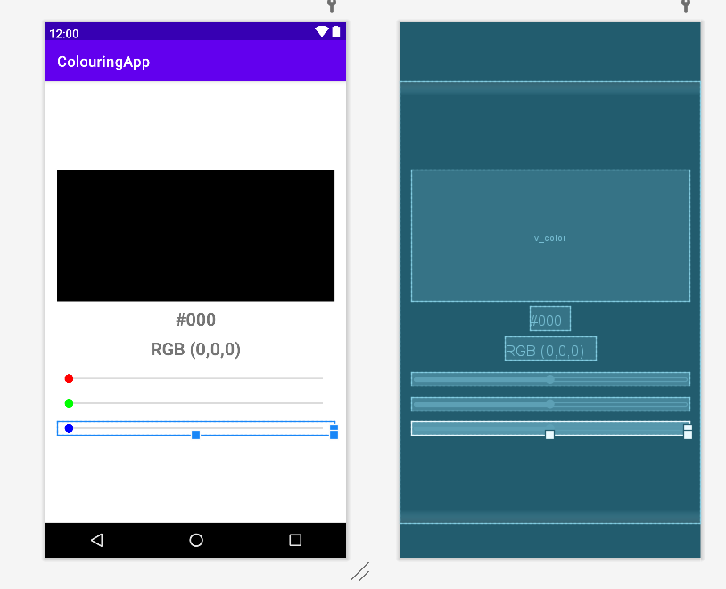

**Application Programming Interface:**

|  |  |  |  |
| --- | --- | --- | --- |
| **API / PACKAGES** | **CLASSES / INTERFACES** | **METHODS** | **DESCRIPTION** |
| import androidx.appcompat.app.AppCompatActivity; | AppCompatActivity | protected void onCreate(Bundle savedInstanceState) | onCreate(Bundle) is where you initialize your activity. When Activity is started and application is not loaded, then both onCreate() methods will be called. |
|  |  |
| import android.widget.EditText; | EditText | getText() | Determines the minimum type that getText() will return. If set, specifies that this TextView has a textual input method and should automatically capitalize what the user types. |

**Code/Implementation:**

// Develop an android application to demonstrate the Implicit and Explicit Intent.

// Project Name : ColouringApp

/*

Lab Session No. : 07

Author : Tellakula Avinash

Date :

Roll Number : 198W1A05C0

Description : Colour based on Color code

Softwares required :

Android Studio

Topics Covered :

UI Input Controls

*/

*MainAcitivity.java*

package com.avinash.colouringapp;  
  
import androidx.appcompat.app.AppCompatActivity;  
  
import android.graphics.Color;  
import android.os.Bundle;  
import android.view.View;  
import android.widget.SeekBar;  
import android.widget.TextView;  
  
import java.util.Locale;  
  
public class MainActivity extends AppCompatActivity implements SeekBar.OnSeekBarChangeListener {  
 View vColor;  
 TextView tvCode,tvValue;  
 SeekBar sbRed,sbGreen,sbBlue;  
 int red=0,green=0,blue=0;  
 @Override  
 protected void onCreate(Bundle savedInstanceState) {  
 super.onCreate(savedInstanceState);  
 setContentView(R.layout.*activity_main*);  
 vColor=findViewById(R.id.*v_color*);  
 tvCode=findViewById(R.id.*tv_code*);  
 tvValue=findViewById(R.id.*tv_value*);  
 sbRed=findViewById(R.id.*sb_red*);  
 sbGreen=findViewById(R.id.*sb_green*);  
 sbBlue=findViewById(R.id.*sb_blue*);  
 sbRed.setOnSeekBarChangeListener(this);  
 sbGreen.setOnSeekBarChangeListener(this);  
 sbBlue.setOnSeekBarChangeListener(this);  
 }  
 @Override  
 public void onProgressChanged(SeekBar seekBar, int progress, boolean fromUser) {  
 switch(seekBar.getId()){  
 case R.id.*sb_red*:  
 red=progress;  
 break;  
 case R.id.*sb_green*:  
 green=progress;  
 break;  
 case R.id.*sb_blue*:  
 blue=progress;  
 break;  
  
 }  
 vColor.setBackgroundColor(Color.*rgb*(red,green,blue));  
 String code=HexCode(red,green,blue);  
 tvCode.setText(code.toUpperCase());  
 tvValue.setText(String.*format*("RGB (%d, %d, %d)",red,green,blue));  
 }  
  
 private String HexCode(int red, int green, int blue) {  
 String code;  
 code="#";  
 code+=Integer.*toHexString*(red);  
 code+=Integer.*toHexString*(green);  
 code+=Integer.*toHexString*(blue);  
 return code;  
 }  
  
  
  
 @Override  
 public void onStartTrackingTouch(SeekBar seekBar) {  
  
 }  
  
 @Override  
 public void onStopTrackingTouch(SeekBar seekBar) {  
  
 }  
}

*activity_main.xml*

*<?*xml version="1.0" encoding="utf-8"*?>*<LinearLayout xmlns:android="http://schemas.android.com/apk/res/android"  
 xmlns:app="http://schemas.android.com/apk/res-auto"  
 xmlns:tools="http://schemas.android.com/tools"  
 android:layout_width="match_parent"  
 android:layout_height="match_parent"  
 android:orientation="vertical"  
 android:gravity="center"  
 android:padding="16dp"  
 tools:context=".MainActivity">  
  
 <View  
 android:layout_height="180dp"  
 android:layout_width="match_parent"  
 android:id="@+id/v_color"  
 android:background="#000"  
 />  
 <TextView  
 android:layout_width="wrap_content"  
 android:layout_height="wrap_content"  
 android:id="@+id/tv_code"  
 android:text="#000"  
 android:textSize="24sp"  
 android:textStyle="bold"  
 android:layout_marginTop="8dp"  
 />  
 <TextView  
 android:layout_width="wrap_content"  
 android:layout_height="wrap_content"  
 android:id="@+id/tv_value"  
 android:text="RGB (0,0,0)"  
 android:textSize="24sp"  
 android:textStyle="bold"  
 android:layout_marginTop="8dp"  
 />  
 <SeekBar  
 android:layout_width="match_parent"  
 android:layout_height="wrap_content"  
 android:id="@+id/sb_red"  
 android:layout_marginTop="16dp"  
 android:max="255"  
 android:progressTint="#FF0000"  
 android:thumbTint="#FF0000"  
 />  
 <SeekBar  
 android:layout_width="match_parent"  
 android:layout_height="wrap_content"  
 android:id="@+id/sb_green"  
 android:layout_marginTop="16dp"  
 android:max="255"  
 android:progressTint="#00FF00"  
 android:thumbTint="#00FF00"  
 />  
 <SeekBar  
 android:layout_width="match_parent"  
 android:layout_height="wrap_content"  
 android:id="@+id/sb_blue"  
 android:layout_marginTop="16dp"  
 android:max="255"  
 android:progressTint="#0000FF"  
 android:thumbTint="#0000FF"  
 />  
</LinearLayout>

**Output:**

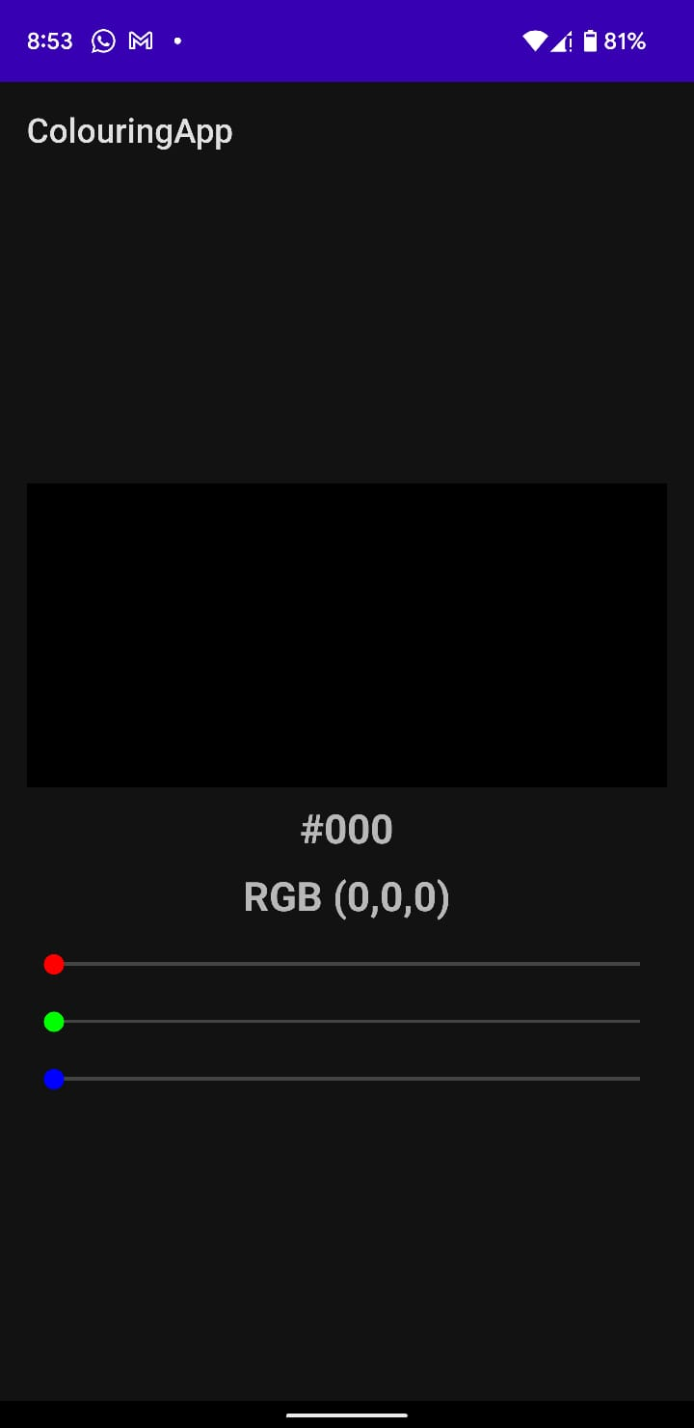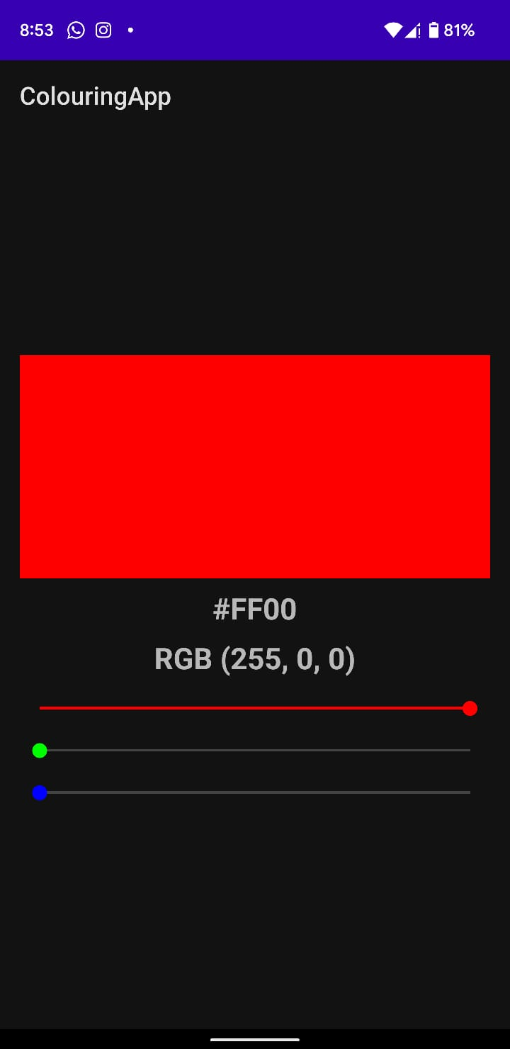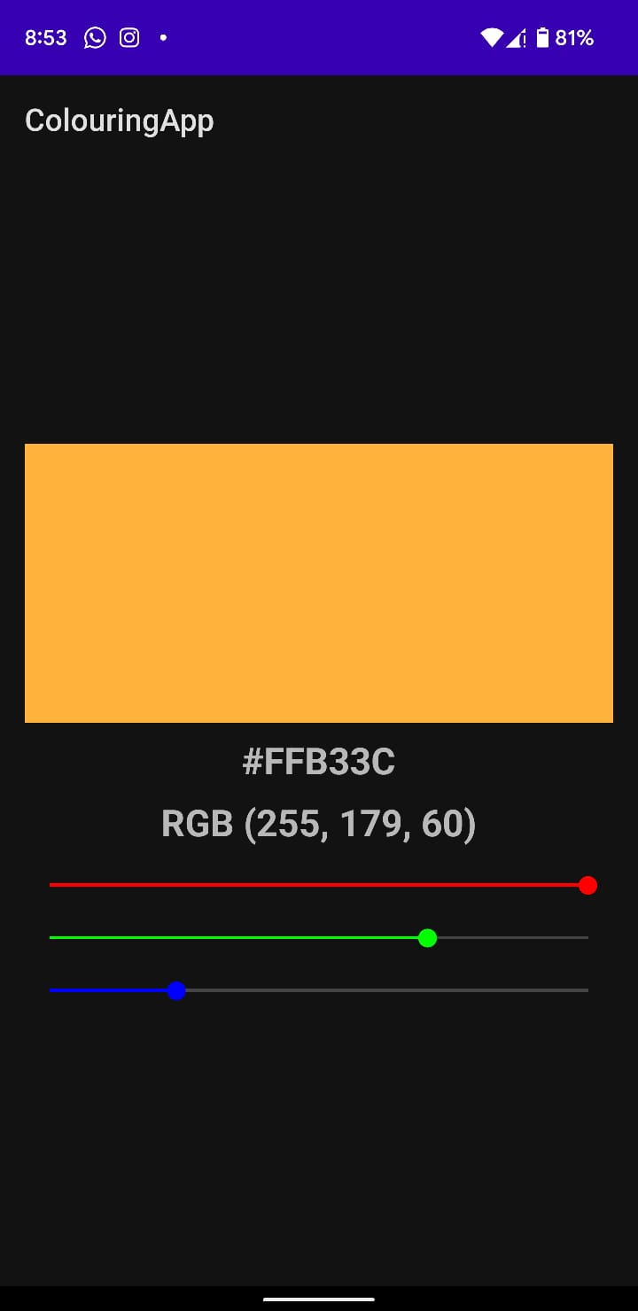

**Result:**

Demonstration input controls available in android were done successfully.